A

Project Report

On

**STUDENT STAFF FEEDBACK SYSTEM**

Submitted in partial fulfillment of the requirements for the award of

**DIPLOMA**

**IN**

**COMPUTER ENGINEERING**

**By**

**MOHAMMED EHTESHAM UDDIN – 14001-CM-039**

**V.BHARGAVI – 14001-CM-060**

**M.SRIKANTH – 14001-CM-061**

**N.MOUNICA – 14001-CM-044**

**K.PRAVALLIKA – 14001-CM-029**

**S.SAISHASHANK – 14001-CM-054**

**D.VENKATESH – 14001-CM-402**



**DEPARTMENT OF COMPUTER ENGINEERING**

**GOVERNMENT POLYTECHNIC**

MASABTANK, HYDERABAD – 500 028

TELANGANA STATE

**GOVERNMENT POLYTECHNIC**

MASABTANK, HYDERABAD – 500 028

TELANGANA STATE



**DEPARTMENT OF COMPUTER ENGINEERING**

**CERTIFICATE**

This is to Certify that the Project report entitled **“EXPENSE MANAGEMENT”** being submitted by

**MOHAMMED EHTESHAM UDDIN – 14001-CM-039**

**V.BHARGAVI – 14001-CM-060**

**M.SRIKANTH – 14001-CM-061**

**N.MOUNICA – 14001-CM-044**

**K.PRAVALLIKA – 14001-CM-029**

**S.SAISHASHANK – 14001-CM-054**

**D.VENKATESH – 14001-CM-402**

In a partial fulfillment of the requirements for the award of **Diploma in Computer Engineering**, State Board of Technical Education & Training is a record of bonafide work carried out by them.

The results presented in this thesis have been verified and are found to be satisfactory.The results embodied in this thesis have not been submitted to any other Board for the award of diploma.

**Internal Guide Head of the Department**

**(G.S.PRAVEENA B.Tech ) (Sri. CH. Sri Ram Kumar M.Tech.)**

**Submitted for the viva voice examination held on ____________________**

**Internal Examiner External Examiner**

**ACKNOWLEDGEMENT**

As endeavor of a long period can be successful only with the advice of my Parents and well-wishers. I now take this opportunity to express my deep gratitude and appreciation to all those who encouraged me for successful completion of the project work.

I wish to express our sincere gratitude to **Sri A. Pullaiah MIE,MISTE Principal**. His consistent help and encouragement to complete the project work.

My special thanks to **Sri. CH. Sri Ram Kumar M.Tech**  **Head of** **Computer Engineering Department, Government Polytechnic** during the process of project work for his timely suggestions and help in spite of his busy schedule.

I am thankful to my guide **G.S.PRAVEENA B.Tech,** Lecturer in **Department of Computer Engineering, Government Polytechnic** for this valuable guidance and suggestions in analyzing and testing throughout the period, till end of project work completion.

I also extend my thanks to the entire Teaching and Non-Teaching faculty ofGovernment Polytechnic, who have encouraged me throughout the course of Diploma in Computer Engineering.

Last but not least, I thank my family and all those helped me directly or indirectly for the completion of the project.

**ABSTRACT**

Online **student staff feedback system** is the web based feedback collecting system from the students and provides the automatic generation of a feedback which is given by students. We have developed student feedback system to provide feedback in a quick and easy manner to the particular department. So we called it a student’s feedback system which delivers via the student staff interface as online system which acting as a service provider. By using this technology we can give feedback in online system as fast as compare to the existing paper feedback system. The existing system carries more time to do a piece of work for this reason the online system feedback is implemented. Students will fill online feedback using a standard form. In this project security is also maintain that is the result of feedback is only visible to authentic user.

In order to maintain a good recognition at college, the management does every possible aspect in maintaining the qualities of the lecturer’s. As this is the online-era, where everything is online we need to develop a system in online which is very useful to maintain feedback reports by the administrator.

The purpose of this project is to make the process of taking feedback from the students in online regarding the lecturer’s teaching. With this, the institutes can access the feedback reports in a faster way and without any loss of data. As of now this task was done manually with the use of papers and pens. This has many drawbacks and evaluating this hand written forms is a difficult process.

Student needs to logging into the website of online feedback system and giving his/her feedback and can perform modifications too. But the restriction here is once the student submits the report then he cannot modify it later. With this the student can successfully submit feedback on lecturer’s teaching in a very efficient manner without any loss of data. The administrator and the faculty members can access these feedbacks from the students and take appropriate actions.

**PREFACE**

This report covers all the information about working of the project and their benefits. In the introduction all the information about the project is given. It also informs about platform on which the project has been developed.

Coding chapter describes the logic of coding that has been done to implement the project, the code like update, insert , retrieve, session variable to identify the current user login to update and some more things has been explained.

System analysis describes existing system, proposed system according to the needs and the feasibility.

System testing informs about the testing module by which system has been tested after testing implementation describes how the user will interact with the system.

In the input/output screen layout input and the output are given, which is important to ensure that the result obtained from this project are correct and reliable. The next chapter about the scope of development indicates the benefits of the project.

**INDEX**

**1. INTRODUCTION**

**1.1 OBJECTIVE**

**1.2 SCOPE**

**2. SYSTEM ANALYSIS**

**2.1 EXISTING SYSTEM DISADAVANTAGES**

**2.2 PROPOSED SYSTEM ADVANTAGES**

**2.3 REQUIREMENTS**

**3. DESIGN**

**3.1 SYSTEM ARCHITECTURE**

**3.2 UML DIAGRAMS**

**3.2.1 CLASS DIAGRAM**

**3.2.2 USE CASE DIAGRAMS**

**3.2.3 STATE DIAGRAMS**

**3.2.4 ACTIVITY**

**4. IMPLEMENTATION**

**5. CODING**

**6. TESTING**

**7. SCREENSHOTS**

**8. FUTURE SCOPE**

**9. CONCLUSION & BIBLIOGRAPHY**

**Introduction**

**1.INTRODUCTION**

The **Online Student Staff Feedback System** is a management information system for education establishments to manage student data. Student Feedback Systems provide capabilities for selecting particular subject for feedback and generate the report automatically, build student details, student-related data needs in a college. A Online Student Feedback System is an automatic feedback generation system that provides the proper feedback to the teachers as per the categories like always, poor, usually, very often, sometimes. In the existing system students can give feedback about the lecturers by doing manually. By this process student can give feedback in online system without wasting his time in writing. After giving feedback by every student papers are collected by the faculty and calculated the overall grade for each subject and each lecturer. After that those all grade report is viewed by the HOD which is given by the faculty. Hence estimating the performance of lecturers and giving feedback to college staff. So, the existing system carries more time to do a piece of work for this reason the online system feedback is implemented. This is the main disadvantage of the existing system for giving feedback about the lecturers and viewing report of lecturers manually. Student feedback on courses is an essential element in quality assurance. Questionnaires are of primary importance in the dialogue with students, since they are the best tool we currently have for collecting objective, detailed and reasonably systematic information on a wide range of questions, which Informs the teacher about student’s perceptions of the course's strengths and weaknesses. Responses are collated on behalf of departments by the system, and will be used only for the purposes of quality enhancement. The aim of this is to save time for staff in academic departments and to allow a minimum level of statistical analysis of the data across the College. This recognizes that whilst the information remains the property of the college.

**1.1 OBJECTIVES**

**Student Staff feedback on study-units has three main objectives:**

1. To provide students with the opportunity to comment on the quality of their learning experiences, as required in preparation for and as part of review processes
2. To assess the success of academic provision in relation to the expectations of students
3. To provide feedback to lecturers in order to improve delivery and/or content of the study-unit
4. Decision making power is provided by this system.
5. Accurate result can be obtained.
6. This system makes Selection process more effective
7. To increase efficiency proposed system is depend on classification method.
8. Proposed system is used to reduce confusion at the time of processing feedback average

**1.2 SCOPE**

**The scope of Student staff feedback system portal is as follows**

1. The student feedback portal provides an easier and quicker way to give ratings to the colleges staffs.
2. Student can rate their faculty members according to their teaching style, knowledge, discipline and punctuality at any time from any place.
3. Through the site data of faculty members and students were managed in quite a simple manner.

Analysis

**CHAPTER 2**

**2. SYSTEM ANALYSIS**

**Project Description:**

This system included four modules which were described below in detail

Student module

Faculty module

Hod module

The core functionalities that are to be included in the system are as follows

STUDENT MODULE:

* Give feedback to the respective department staff members.
* Can give comments/message to the respective staff members.

FACULTY MODULE:

* Can view their only comments/message and rating criteria given by students.
* Can view total evaluated feedback.

HOD MODULE:

* Can view result of their respective department.
* Can give suggestions to staff member or student according to their particular comments.
* Submit feedback results to the principal.

**2.1 EXISTING SYSTEM**

Coming to the existing system the feedback is done by manual process. In the existing about Student can give feedback about the lectures by using paper and pen. By this process Student can give feedback in online system without waste his time in writing. After giving feedback by every student. Papers are collected by the Hod’s and calculate the overall grade for each subject and each lecturer. After that those all grade report is viewed by the principal which is given by the Hod’s. Hence estimating the performance of lecturers and giving counselling to college staff.

So, the existing system is carries more time to do a piece of work for this reason the online system feedback is implemented.

This is the major advantage of the existing system for giving feedback about the Lecturers and viewing report of lecturers.

**Disadvantages**

1. It’s too tiring to give Computerised Timing.

2. Security Limitations

3. Only Works on Intranet.

**2.2 PROPOSED SYSTEM**

Here we aimed to design online web application for issuing the feedback about the lecturer by students, this is named as Student Staff Feedback System. Student Staff Feedback System to provide feedback in a easy and quick manner to the college principal and Hod’s. So we call it as Student Staff Feedback System which delivers via the student staff interface as online system which acting as a Service Provider.

By using this technology we can make fast feedback about the staff by students on time to head of departments as they referred in online system.

This project has four kinds of users Student, Staff, Hod’s, and Principal. The student can give feedback in online system provided by college staff. First of staff can prepare questions add, update these questions to the online system. After that it was viewed by the students and can give feedback about the lectures.

This feedback report were checked by the Hod’s. He can view overall grades and view the grades obtained to the lectures and give this report to the principal and he give counseling to the college staff..

As compared to manual system, Online system is very simple to use and also understand.

**ADVANTAGES**

**This Project is beneficial for college use.**

1. Decreases the time consumption

2. Improves Efficiency- It improves efficiency

3. Occurrences of Error is Minimise

4. Decreases the paper and labour work

5. Manage the entire process

* 1. **REQUIREMENTS**
* **HARDWARE REQUIREMENTS:**

Processor: I3

Primary Memory: 4 GB

Hard disk: 100 GB

* **SOFTWARE REQUIREMENTS:**

Languages used:

Front End: ASP.NET

Back End: My SQL

Platform: WINDOWS 8

Tools used: Microsoft Visual Studio, internet explorer, Mozilla Firefox.

Design

**CHAPTER 3**

**3.SYSTEM DESIGN**

Software design is an interactive process through which requirements are translated into a ‘Blue print’ for constructing the software. The design represented at high level of abstraction, a level can be directly translated to specific data, functional and behavioural requirements. Preliminary design is concerned with the transformation of requirements into data and software architecture. Detained design focuses on refinements to the architectural representation that lead to detailed data structure of algorithmic representation for software

**3.1 SYSTEM ARCHITECTURE**

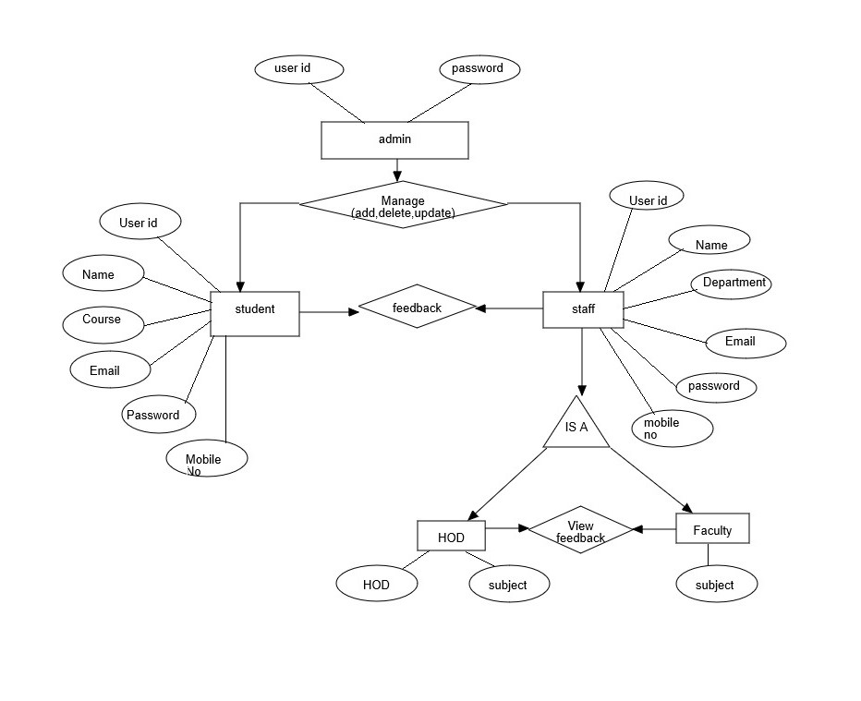

Figure 3.1 system architecture

**3.2 UML DIAGRAMS.**

The Unified Modeling language (UML) is a general purpose, developmental, modelling language in the field of software engineering, that is intended to provide a standard way to visualize the design of a system.

**3.2.1 CLASS DIAGRAM**

In software engineering, a class diagram is a type of static structure diagram that describes the structure of a system by showing the system’s classes, their attributes, their operations (or methods) and the relationships among objects.

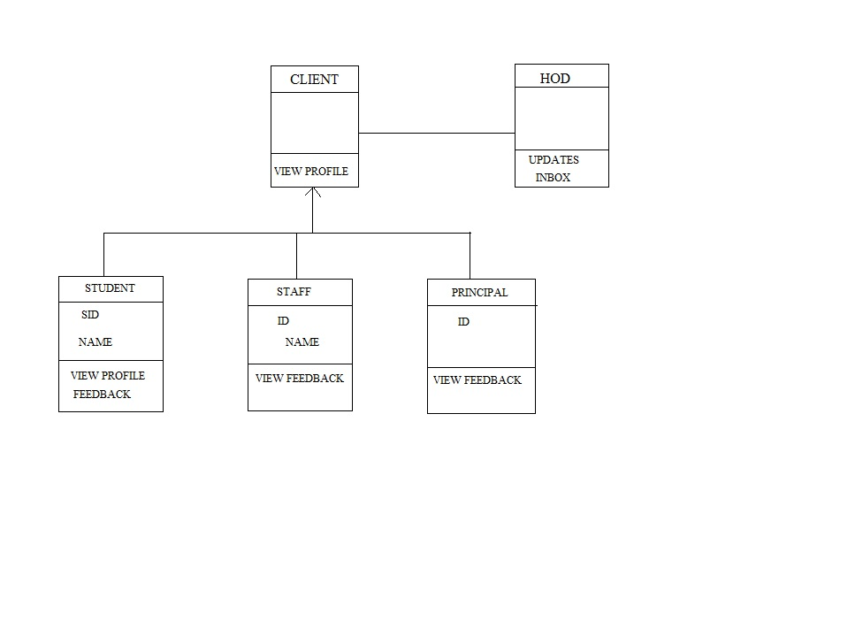

Figure 3.1.1 class diagram

**3.2.2 USE CASE DIAGRAMS**

UML Use Case Diagrams are usually referred to as behaviour diagrams used to describe a set of actions that some system or systems should or can perform in collaboration with one or more external users of the system.

**USE CASE DIAGRAM**

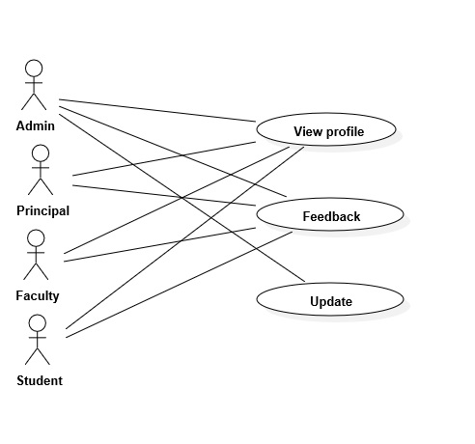

Figure 3.2.2 (a) use case diagra

**3.2.3 STATE DIAGRAM**

A state diagram is a type of diagram used in computer science and related fields to describe the behaviour of systems. State diagrams required that system described is composed of a finite number of states, sometimes, this is indeed the case, while at other times this is a reasonable abstraction.

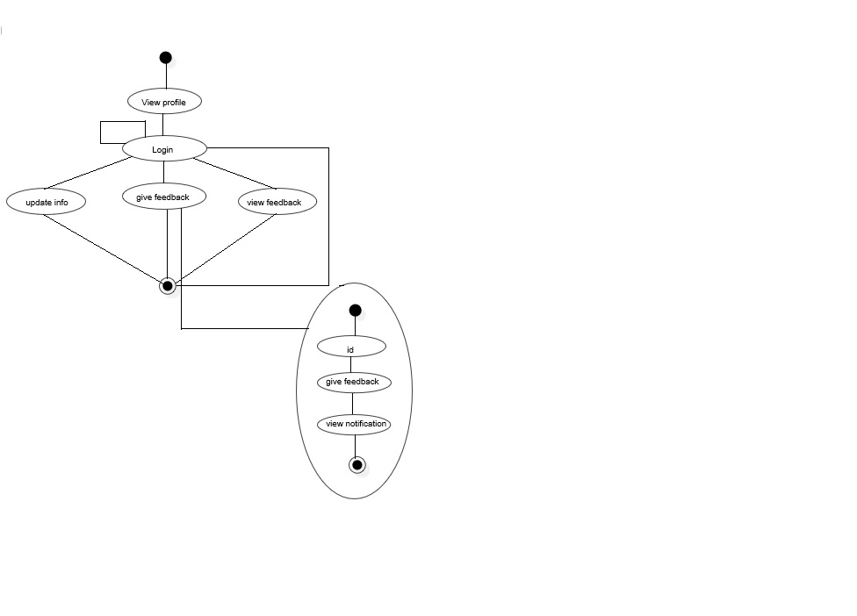

Figure 3.2.3 state diagram

**3.2.4 ACIVITY DIAGRAM**

Activity diagrams are graphical representations of workflows of stepwise activities and actions which support for choice, iteration and concurrency. In Unified Modelling Language, activity diagrams are intended to model both computational and organizational processes (i.e. workflows).

ACTIVITY DIAGRAM

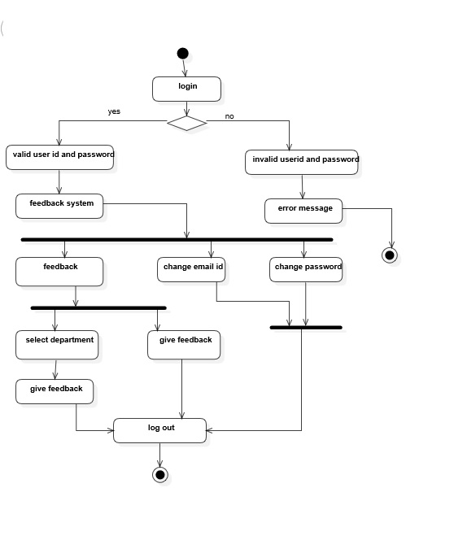

Figure 3.2.4 Activity diagram

**CHAPTER 4**

**4.1 IMPLEMENTATION**

In this project we implemented the system which works on the concept of online feedback from students which is the replacement of existing paper feedback system which is so complicated method for finding an average for particular subject feedback which is submitted by students.

In this system we have design main three forms student login form, admin login form, faculty login form. Student will login in their login form with proper id and password which is provided by admin at the time of registration. After that if student want any changes in his profile then there is an option for edit such particular information of his own. After that the subject contains page is displayed, where the subject is located in it and as per the selection from student students continued to their feedback after this page the feedback page is displayed.

This page contains a form which includes such questions about the teachers where it contains some simple question regarding particular subject faculty. After giving the feedback the page appeared which contains a message like you are feedback is submitted. Then after feedback is submitted there is a log out button after click on it student will successfully log out from their profile. In main page it contains some hyperlinks like contact us, frequently ask questions, and submit the queries. And contains three particular modules like student login, admin login, staff login etc. Admin will fill the information of students as well as view their feedback, add and delete student and generate the average report of that feedback. After that log out button occurs and admin simply logout from the system. Student will login by using user id and password and after the login page will be open contains subjects, suggestion box, submit suggestions, submit feedback and after their occurs a log out button for logout successfully from the system**.**

Coding

MAIN PAGE:

<%@ Page Language="C#" AutoEventWireup="true" CodeFile="ssmainpage.aspx.cs" Inherits="_Default" %>

<!DOCTYPE html PUBLIC "-//W3C//DTD XHTML 1.0 Transitional//EN" "http://www.w3.org/TR/xhtml1/DTD/xhtml1-transitional.dtd">

<html xmlns="http://www.w3.org/1999/xhtml">

<head runat="server">

<title></title>

<style type="text/css">

.style1

{

width: 1164px;

}

.style2

{

width: 1539px;

}

.style6

{

width: 1390px;

}

#form1

{

height: 672px;

width: 1332px;

}

.style21

{

height: 61px;

}

.style22

{

width: 883px;

}

.style23

{

width: 100%;

height: 474px;

}

.style25

{

width: 691px;

}

.auto-style2 {

width: 372px;

height: 78px;

}

.auto-style5 {

width: 460px;

height: 78px;

}

.auto-style7 {

color: #FFFFFF;

}

.auto-style8 {

}

.auto-style9 {

width: 375px;

height: 78px;

}

</style>

</head>

<body style="height: 676px; width: 1328px;">

<form id="form1" runat="server">

<asp:Panel ID="Panel1" runat="server" BackColor="blue" BorderStyle="Solid"

Font-Size="XX-Large" ForeColor="White" Height="106px">

<center style="height: 669px; background-color: #003399;">

<br />

&nbsp;&nbsp;&nbsp;&nbsp;&nbsp;&nbsp;&nbsp; STUDENT STAFF FEEDBACK SYSTEM&nbsp;&nbsp;&nbsp;&nbsp;&nbsp;&nbsp;&nbsp;&nbsp; </center></asp:Panel>

<asp:Panel ID="Panel2" runat="server" BorderStyle="Groove" Height="549px"

BackColor="White" style="margin-top: 3px" BackImageUrl="~/images/SE.jpg" BorderColor="White">

<table border="5" cellpadding="10" cellspacing="5" frame="box" class="style21">

<tr>

<td class="auto-style2" bgcolor="Transparent">&nbsp;&nbsp;&nbsp;&nbsp;&nbsp;&nbsp;&nbsp;&nbsp;&nbsp;&nbsp;&nbsp;&nbsp;&nbsp;&nbsp;&nbsp;&nbsp;&nbsp;&nbsp;&nbsp;&nbsp;&nbsp;<asp:HyperLink ID="HyperLink5" runat="server" CssClass="auto-style7" Font-Bold="True" Font-Names="Cambria" Font-Underline="True" ForeColor="Black" NavigateUrl="~/STUDENTSELECT.aspx" Font-Size="X-Large">STUDENT</asp:HyperLink>

&nbsp;&nbsp;&nbsp;&nbsp;&nbsp;&nbsp;&nbsp;&nbsp;&nbsp;&nbsp;&nbsp;&nbsp;&nbsp;&nbsp;&nbsp;&nbsp;

</td>

<td class="auto-style5" bgcolor="Transparent">&nbsp;&nbsp;&nbsp;&nbsp;&nbsp;&nbsp;&nbsp;&nbsp;&nbsp;&nbsp;&nbsp;&nbsp;&nbsp;&nbsp;&nbsp;&nbsp;&nbsp;&nbsp;&nbsp;&nbsp;&nbsp; &nbsp;&nbsp;&nbsp;&nbsp;&nbsp;&nbsp;&nbsp;

<asp:HyperLink ID="HyperLink6" runat="server" Font-Bold="True" Font-Underline="True" ForeColor="Black" NavigateUrl="~/stafflogin.aspx" Font-Size="X-Large">STAFF</asp:HyperLink>

</td>

<td class="auto-style9" bgcolor="Transparent">&nbsp;&nbsp;&nbsp;&nbsp;&nbsp;&nbsp;&nbsp;&nbsp;&nbsp;&nbsp;&nbsp;&nbsp;&nbsp;&nbsp;&nbsp;&nbsp;&nbsp;&nbsp;&nbsp;<br /> &nbsp;&nbsp;&nbsp;&nbsp;&nbsp;&nbsp;&nbsp;&nbsp;&nbsp;&nbsp;&nbsp;&nbsp;&nbsp;&nbsp;&nbsp;&nbsp;&nbsp;&nbsp;&nbsp;&nbsp;&nbsp;&nbsp; &nbsp;&nbsp;&nbsp;<asp:HyperLink ID="HOD" runat="server" Font-Underline="True"

NavigateUrl="~/hodLOGINPAGE.aspx" Font-Bold="True" Font-Names="Cambria"

ForeColor="Black" Font-Size="X-Large">HOD</asp:HyperLink>

&nbsp;&nbsp;&nbsp;&nbsp;&nbsp;&nbsp;&nbsp;&nbsp;&nbsp;&nbsp;&nbsp;&nbsp;&nbsp;&nbsp;&nbsp;&nbsp;&nbsp;&nbsp;&nbsp;&nbsp;&nbsp;&nbsp;&nbsp;&nbsp;&nbsp;&nbsp;&nbsp;&nbsp;&nbsp; &nbsp;&nbsp;&nbsp;&nbsp; &nbsp;&nbsp;&nbsp;&nbsp;</td>

<td bgcolor="Transparent" class="auto-style9">&nbsp;&nbsp;&nbsp;&nbsp;&nbsp;&nbsp;&nbsp;&nbsp;&nbsp;&nbsp;&nbsp;&nbsp;&nbsp;&nbsp;&nbsp;&nbsp;&nbsp;&nbsp;&nbsp;&nbsp;&nbsp;&nbsp;&nbsp;&nbsp;

<asp:HyperLink ID="HyperLink3" runat="server" Font-Bold="True" Font-Names="Cambria" Font-Underline="True" ForeColor="Black" NavigateUrl="~/about.aspx" Font-Size="X-Large">ABOUT</asp:HyperLink>

</td>

</tr>

</table>

<table class="style23">

<tr>

<td class="auto-style8">

&nbsp;&nbsp;&nbsp;&nbsp;&nbsp;

<asp:Panel ID="Panel3" runat="server" Height="428px" Width="1317px" BackColor="Transparent" style="margin-top: 0px" ForeColor="White">

<p style="height: 426px; width: 1315px;">

&nbsp;&nbsp;&nbsp;&nbsp;&nbsp;&nbsp; &nbsp;&nbsp;&nbsp;&nbsp;

<br />

<br />

<br />

<strong>

<em style="font-family: Cambria; font-size: x-large; font-style: normal; font-variant: normal">

&nbsp;&nbsp;&nbsp;&nbsp;&nbsp;&nbsp;&nbsp;&nbsp;&nbsp;&nbsp;&nbsp;&nbsp;&nbsp;&nbsp;&nbsp;&nbspnbsp;&nbsp;&nbsp; <strong><em style="font-family: Cambria; font-size: x-large; font-style: normal; font-variant: normal">&nbsp;&nbsp;&nbsp;&nbsp;&nbsp;&nbsp;&nbsp;&nbsp;&nbsp;&nbsp;&nbsp;&nbsp;&nbsp;&nbsp;&nbsp;&nbsp;&nbsp;&nbsp;&nbsp;&nbsp;&nbsp;&nbsp;&nbsp;&nbsp;&nbsp;&nbsp;&nbsp;&nbsp;&nbsp;&nbsp;&nbsp;&nbsp;&nbsp;&nbsp;&nbsp;&nbsp;&nbsp;&nbsp;&nbsp;&nbsp;&nbsp;&nbsp;&nbsp;&nbsp;&nbsp;&nbsp;&nbsp;&nbsp;&nbsp;&nbsp;&nbsp;&nbsp;&nb;&nbsp;&nbsp;&nbsp;&nbsp;&nbsp;&nbsp;&nbsp;&nbsp;&nbsp;&nbsp;&nbsp;&nbsp;&nbsp;&nbsp;&nbsp; </em></strong>&nbsp<strong><em style="font-family: Cambria; font-size: x-large; font-style: normal; font-variant: normal">Lecturer&nbsp;&nbsp; cannot&nbsp;&nbsp; work&nbsp;&nbsp; in&nbsp;&nbsp; a&nbsp;&nbsp; vaccum.&nbsp; They&nbsp;&nbsp; many</em></strong>

<strong>

<em style="font-family: Cambria; font-size: x-large; font-style: normal; font-variant: normal">

take&nbsp;&nbsp; on&nbsp;&nbsp; larger ,&nbsp; seemingly&nbsp;&nbsp; more&nbsp;&nbsp;&nbsp; important&nbsp;&nbsp; roles&nbsp;&nbsp; in&nbsp;&nbsp;&nbsp; an&nbsp; organization , but&nbsp;&nbsp; this&nbsp;&nbsp; does&nbsp;&nbsp; not&nbsp;&nbsp; exclude&nbsp;&nbsp; them&nbsp;&nbsp; from asking&nbsp;&nbsp; for&nbsp;&nbsp; and&nbsp;&nbsp; using&nbsp;&nbsp; feedback .&nbsp; In&nbsp;&nbsp; fact ,&nbsp; a&nbsp;&nbsp; leader&nbsp; arguably needs&nbsp;&nbsp; feedback&nbsp;&nbsp; more&nbsp;&nbsp; so&nbsp;&nbsp; than&nbsp;&nbsp; anyone&nbsp;&nbsp; else .&nbsp; It&#39;s&nbsp;&nbsp; what&nbsp;&nbsp; help&nbsp;&nbsp; a&nbsp;&nbsp; lecturer&nbsp;&nbsp; respond&nbsp;&nbsp; appropriately&nbsp;&nbsp; to&nbsp;&nbsp; events&nbsp;&nbsp; in&nbsp;&nbsp; pursuit&nbsp;&nbsp; of&nbsp;&nbsp; successful&nbsp;&nbsp; outcomes.</em></strong></p>

</asp:Panel>

&nbsp;<br /> &nbsp;&nbsp;&nbsp;

<br />

&nbsp;</td>

</tr>

</table>

&nbsp;&nbsp;&nbsp;&nbsp;&nbsp;&nbsp;&nbsp;&nbsp;&nbsp;&nbsp;&nbsp;&nbsp;&nbsp;

<br />

</asp:Panel>

</form>

</body>

</html>

STUDENT LOGINPAGE:

<%@ Page Language="C#" AutoEventWireup="true" CodeFile="studentlogin1.aspx.cs" Inherits="_Default" %>

<!DOCTYPE html PUBLIC "-//W3C//DTD XHTML 1.0 Transitional//EN" "http://www.w3.org/TR/xhtml1/DTD/xhtml1-transitional.dtd">

<html xmlns="http://www.w3.org/1999/xhtml">

<head runat="server">

<title></title>

<style type="text/css">

.dropbtn {

border-style: none;

border-color: inherit;

border-width: medium;

background-color: #4CAF50;

color: white;

padding: 16px;

font-size: 16px;

cursor: pointer;

width: 95px;

}

.dropdown {

position: relative;

display: inline-block;

top: 0px;

left: 0px;

height: 56px;

width: 135px;

}

.dropdown-content {

display: none;

position: absolute;

background-color: #f9f9f9;

min-width: 160px;

box-shadow: 0px 8px 16px 0px rgba(0,0,0,0.2);

z-index: 1;

}

.dropdown-content a {

color: black;

padding: 12px 16px;

text-decoration: none;

display: block;

}

.dropdown-content a:hover {background-color: #f1f1f1}

.dropdown:hover .dropdown-content {

display: block;

}

.dropdown:hover .dropbtn {

background-color: #3e8e41;

}

.button {

border-top: 1px solid #96d1f8;

background: #65a9d7;

background: -webkit-gradient(linear, left top, left bottom, from(#3e779d), to(#65a9d7));

background: -webkit-linear-gradient(top, #3e779d, #65a9d7);

background: -moz-linear-gradient(top, #3e779d, #65a9d7);

background: -ms-linear-gradient(top, #3e779d, #65a9d7);

background: #65a9d7;

padding: 9px 18px;

-webkit-border-radius: 15px;

-moz-border-radius: 15px;

border-radius: 15px;

-webkit-box-shadow: rgba(0,0,0,1) 0 1px 0;

-moz-box-shadow: rgba(0,0,0,1) 0 1px 0;

box-shadow: rgba(0,0,0,1) 0 1px 0;

text-shadow: rgba(0,0,0,.4) 0 1px 0;

color: white;

font-size: 19px;

font-family: Helvetica, Arial, Sans-Serif;

text-decoration: none;

vertical-align: middle;

margin-left: 0px;

margin-top: 0px;

}

.button:hover {

border-top-color: #28597a;

background: #28597a;

color: #ccc;

}

.button:active {

border-top-color: #1b435e;

background: #1b435e;

}

.textbox {

background: #333;

color: #ccc;

width: 168px;

padding: 6px 15px 6px 35px;

border-radius: 20px;

box-shadow: 0 1px 0 #ccc inset;

transition: 500ms all ease;

outline: 0;

}

.textbox:hover {

width: 270px;

}

.style1

{

width: 100%;

height: 175px;

}

.style2

{

width: 689px;

color: #FFFFFF;

font-size: xx-large;

font-family: Tahoma;

}

.style5

{

color: #FFFFFF;

}

.style7

{

width: 100%;

height: 500px;

}

.style8

{

width: 100%;

height: 475px;

}

.style9

{

width: 698px;

}

.style10

{

font-size: x-large;

}

.style11

{

width: 327px;

color: #FFFFFF;

}

.style14

{

width: 327px;

}

.style16

{

height: 30px;

}

.style18

{

width: 338px;

height: 149px;

}

.style21

{

height: 39px;

}

.style23

{

height: 37px;

}

.style26

{

height: 31px;

}

.style27

{

height: 39px;

width: 426px;

}

.style30

{

height: 37px;

width: 426px;

}

.style34

{

}

.style38

{

height: 58px;

}

.style41

{

width: 600px;

height: 463px;

}

.style44

{

height: 53px;

}

.style51

{

width: 426px;

margin-left: 80px;

}

.style52

{

height: 30px;

width: 426px;

}

.style53

{

width: 426px;

font-weight: bold;

text-align: right;

}

.style54

{

height: 37px;

width: 426px;

font-weight: bold;

text-align: right;

}

.style55

{

height: 30px;

font-weight: bold;

text-align: right;

}

.style56

{

height: 39px;

width: 426px;

font-weight: bold;

text-align: right;

}

#Reset1 {

height: 46px;

width: 167px;

}

.auto-style1 {

height: 30px;

font-weight: bold;

text-align: right;

color: #FF0000;

font-size: medium;

}

</style>

</head>

<body style="height: 710px">

<form id="form1" runat="server">

<div>

&nbsp;<asp:Panel ID="Panel1" runat="server"

BackImageUrl="" Height="801px" Width="1359px">

<table bgcolor="#003399" class="style1">

<tr>

<td class="style2" rowspan="4">

<strong>STUDENT STAFF FEEDBACK SYSTEM</strong></td>

</tr>

<tr>

<td class="style11">

USERNAME</td>

<td>

&nbsp;&nbsp;

<span class="style5">PASSWORD&nbsp;&nbsp;

</span>

</td>

</tr>

<tr>

<td class="style14">

<asp:TextBox ID="TextBox17" runat="server" BackColor="Transparent"

BorderColor="White" BorderStyle="Outset" BorderWidth="2px" ForeColor="White"

Height="32px" style="margin-left: 15px; margin-top: 0px;"

Width="213px" Font-Bold="True" Font-Size="Large"></asp:TextBox>

<td>

<asp:TextBox ID="TextBox18" runat="server" BackColor="Transparent"

BorderColor="White" BorderStyle="Outset" BorderWidth="2px" ForeColor="White"

Height="32px" style="margin-left: 7px; margin-top: 30px;" Width="213px" TextMode="Password" Font-Bold="True" Font-Size="Large"

>*</asp:TextBox>

&nbsp;<br>

<asp:Button ID="Button1" runat="server" BackColor="#3366CC" BorderColor="White"

BorderStyle="Outset" BorderWidth="2px" ForeColor="White" Height="27px"

Text="Login" Width="66px" OnClick="Button1_Click1" />

</td>

</tr>

<tr>

<td class="style14">

</td>

<td>

<asp:HyperLink ID="HyperLink1" runat="server" style="color: #FFFFFF"

NavigateUrl="~/Forgotpassword.aspx">Forgot password?</asp:HyperLink>

</td>

</tr>

</table>

<br />

<table class="style7">

<tr>

<td class="style9">

<table class="style8">

<tr>

<td class="style26" colspan="3" style="font-size: 18px; color: #003399">

&nbsp;&nbsp;&nbsp;&nbsp;&nbsp;&nbsp;&nbsp;&nbsp;&nbsp;&nbsp;&nbsp;&nbsp;&nbsp;&nbsp;&nbsp;&nbsp;&nbsp;&nbsp;&nbsp;&nbsp;&nbsp;&nbsp;&nbsp;&nbsp;&nbsp;&nbsp;&nbsp;&nbsp;&nbsp;&nbsp;&nbsp;&nbsp;&nbsp;&nbsp;&nbsp;&nbsp; &nbsp;&nbsp;&nbsp;&nbsp;&nbsp; <strong>

<span class="style10" style="font-size: 30px">New user? sign up</span></strong></td>

</tr>

<tr>

<td class="style26" colspan="3">

&nbsp;</td>

</tr>

<tr>

<td class="style56">

<strong>USER NAME :</strong></td>

<td class="style27">

<asp:TextBox ID="TextBox11" runat="server" BackColor="#003399"

BorderColor="#CCCCCC" BorderStyle="Outset" BorderWidth="2px" ForeColor="White"

Height="26px" Width="166px" Font-Bold="True" Font-Size="Large"></asp:TextBox>

</td>

<td class="style21">

&nbsp;</td>

</tr>

<tr>

<td class="style53">

PASSWORD: </td>

<td class="style51">

<asp:TextBox ID="TextBox12" runat="server" BackColor="#003399"

BorderColor="#CCCCCC" BorderStyle="Outset" BorderWidth="2px" ForeColor="White"

Height="26px" Width="166px" TextMode="Password" Font-Bold="True" Font-Size="Large">*</asp:TextBox>

</td>

<td>

&nbsp;</td>

</tr>

<tr>

<td class="style55">

CONFIRM PASSWORD: </td>

<td class="style52">

<asp:TextBox ID="TextBox13" runat="server" BackColor="#003399"

BorderColor="#CCCCCC" BorderStyle="Outset" BorderWidth="2px" ForeColor="White"

Height="26px" Width="166px" TextMode="Password" Font-Bold="True" Font-Size="Large">*</asp:TextBox>

</td>

<td class="style16">

&nbsp;</td>

</tr>

<tr>

<td class="style55">

PIN NO : </td>

<td class="style52">

<asp:TextBox ID="TextBox14" runat="server" BackColor="#003399"

BorderColor="#CCCCCC" BorderStyle="Outset" BorderWidth="2px" ForeColor="White"

Height="26px" Width="166px" Font-Bold="True" Font-Size="Large"></asp:TextBox>

</td>

<td class="style16">

<asp:Panel ID="Panel2" runat="server" Height="37px">

</asp:Panel>

</td>

</tr>

<tr>

<td class="auto-style1" colspan="2">If you ever lose your password,we will ask you the following question and we display the password.</td>

<td class="style16">&nbsp;</td>

</tr>

<tr>

<td class="style54">

QUESTION : </td>

<td class="style30">

<asp:TextBox ID="TextBox15" runat="server" BackColor="#003399"

BorderColor="#CCCCCC" BorderStyle="Outset" BorderWidth="2px" ForeColor="White"

Height="26px" Width="166px" Font-Bold="True" Font-Size="Large" OnTextChanged="TextBox15_TextChanged"></asp:TextBox>

</td>

<td class="style23">

&nbsp;</td>

</tr>

<tr>

<td class="style53">

ANSWER : </td>

<td class="style51">

<asp:TextBox ID="TextBox16" runat="server" BackColor="#003399"

BorderColor="#CCCCCC" BorderStyle="Outset" BorderWidth="2px" ForeColor="White"

Height="26px" Width="166px" Font-Bold="True" Font-Size="Large"></asp:TextBox>

</td>

<td>

&nbsp;</td>

</tr>

<tr>

<td class="style51">

</td>

<td class="style51">

&nbsp;</td>

<td>

&nbsp;</td>

</tr>

<tr>

<td class="style38" colspan="3">

&nbsp;&nbsp;&nbsp;&nbsp;&nbsp;&nbsp;&nbsp;&nbsp;&nbsp;&nbsp;&nbsp;&nbsp;&nbsp;&nbsp;&nbsp;&nbsp;&nbsp;&nbsp;&nbsp;

<asp:DropDownList ID="DropDownList1" runat="server" Height="21px" style="margin-left: 123px; margin-top: 0px" Width="99px">

<asp:ListItem>YEAR</asp:ListItem>

<asp:ListItem>I YEAR</asp:ListItem>

<asp:ListItem>II YEAR</asp:ListItem>

<asp:ListItem>III YEAR</asp:ListItem>

</asp:DropDownList>

<asp:DropDownList ID="DropDownList2" runat="server" Height="21px"

style="margin-left: 63px" Width="109px">

<asp:ListItem>SHIFT</asp:ListItem>

<asp:ListItem>I SHIFT</asp:ListItem>

<asp:ListItem>II SHIFT</asp:ListItem>

</asp:DropDownList>

</td>

</tr>

<tr>

<td class="style44" colspan="3">

&nbsp;&nbsp;&nbsp;&nbsp;&nbsp;&nbsp;&nbsp;&nbsp;&nbsp;&nbsp;&nbsp;&nbsp;&nbsp;&nbsp;&nbsp;&nbsp;&nbsp;&nbsp;&nbsp;&nbsp;&nbsp;&nbsp;&nbsp;

<asp:DropDownList ID="DropDownList3" runat="server" Height="23px" style="margin-left: 192px" Width="101px">

<asp:ListItem>GENDER</asp:ListItem>

<asp:ListItem>MALE</asp:ListItem>

<asp:ListItem>FEMALE</asp:ListItem>

</asp:DropDownList>

</td>

</tr>

<tr>

<td class="style34" colspan="3">

&nbsp;&nbsp;&nbsp;&nbsp;&nbsp;&nbsp;&nbsp;&nbsp;&nbsp;&nbsp;&nbsp;&nbsp;&nbsp;&nbsp;&nbsp;&nbsp;&nbsp; &nbsp;&nbsp;

<asp:Button ID="Button2" runat="server"

Text="CREATE ACCOUNT" BackColor="#000099" BorderColor="White"

onclick="Button2_Click1" Height="45px" Width="167px" Font-Bold="True" Font-Size="10pt" ForeColor="White" />

&nbsp;&nbsp;&nbsp;&nbsp;&nbsp;&nbsp;&nbsp;&nbsp;&nbsp;&nbsp;&nbsp;&nbsp;&nbsp;&nbsp;&nbsp;&nbsp;&nbsp;&nbsp;&nbsp;&nbsp;&nbsp;&nbsp;&nbsp;&nbsp;&nbsp;&nbsp;&nbsp;&nbsp;&nbsp;&nbsp;&nbsp;&nbsp;&nbsp;&nbsp;&nbsp;&nbsp;&nbsp;&nbsp;&nbsp;&nbsp;

<input id="Reset1" type="reset" value="RESET" style="background-color: #000099; color: #FFFFFF; font-style: normal; margin-top: 12px;" />

</td>

</tr>

<tr>

<td class="style51">

&nbsp;</td>

<td class="style51">

&nbsp;</td>

<td>

&nbsp;</td>

</tr>

</table>

</td>

<td>

&nbsp;&nbsp;&nbsp;&nbsp;&nbsp;&nbsp;&nbsp;&nbsp;&nbsp;&nbsp;&nbsp;&nbsp;&nbsp;&nbsp;&nbsp;&nbsp;&nbsp;&nbsp;&nbsp;&nbsp;&nbsp;&nbsp;&nbsp;&nbsp;&nbsp;&nbsp;&nbsp;&nbsp;&nbsp;&nbsp;

<img alt="" class="style18"

src="images/feedback%20(1).png" />

<br />

<br />

<img alt="" class="style41"

src="images/feedbackasas.png" />

<br />

<br />

</td>

</tr>

</table>

</asp:Panel>

</div>

</form>

</body>

</html>

STUDENT GIVING FEEDBACK:

<%@ Page Language="C#" AutoEventWireup="true" CodeFile="EDITEDFEEDBACK.aspx.cs" Inherits="EDITEDFEEDBACK" %>

<!DOCTYPE html>

<html xmlns="http://www.w3.org/1999/xhtml">

<head runat="server">

<title></title>

<style type="text/css">

.auto-style1 {

width: 100%;

height: 900px;

}

.auto-style2 {

width: 335px;

}

.auto-style3 {

height: 105px;

}

.auto-style6 {

width: 100%;

height: 651px;

}

.auto-style9 {

width: 174px;

}

.auto-style11 {

width: 6px;

}

.auto-style12 {}

.auto-style13 {

height: 22px;

}

.auto-style14 {

height: 106px;

}

.auto-style19 {

height: 20px;

}

.auto-style20 {

height: 72px;

}

</style>

</head>

<body>

<form id="form1" runat="server">

<div style="height: 589px">

<asp:Panel ID="Panel1" runat="server" Height="900px" style="margin-bottom: 28px" Width="1360px" BackImageUrl="~/images/stdfbbck.jpg">

<table class="auto-style1">

<tr>

<td class="auto-style3" colspan="4">

<asp:Panel ID="Panel2" runat="server" BackColor="#003399" Height="132px">

<asp:TextBox ID="TextBox1" runat="server" BackColor="Transparent" BorderColor="#003399" BorderWidth="0px" Font-Bold="True" Font-Names="Cambria" Font-Size="25pt" ForeColor="White" Height="65px" style="margin-left: 428px; margin-top: 39px" Width="628px"> STUDENT STAFF FEEDBACK</asp:TextBox>

</asp:Panel>

</td>

</tr>

<tr>

<td class="auto-style9">&nbsp;</td>

<td colspan="2" rowspan="7">

<asp:Panel ID="Panel3" runat="server" BackColor="Transparent" Height="655px" style="margin-left: 80px; margin-top: 0px;" Width="788px" BorderColor="White" BorderStyle="Outset" BorderWidth="3px">

<table class="auto-style6">

<tr>

<td>&nbsp;</td>

<td class="auto-style12">&nbsp;</td>

<td>&nbsp;</td>

<td>&nbsp;</td>

</tr>

<tr>

<td>&nbsp;</td>

<td class="auto-style12" colspan="2">

<asp:DropDownList ID="DropDownList1" runat="server" Height="39px" style="margin-left: 293px" Width="197px" BackColor="Transparent" Font-Bold="True">

<asp:ListItem>SELECT LECTURER</asp:ListItem>

<asp:ListItem>SRI RAM Sir</asp:ListItem>

<asp:ListItem>SURESH</asp:ListItem>

<asp:ListItem>RAJU</asp:ListItem>

<asp:ListItem>SRINIVAS</asp:ListItem>

<asp:ListItem>RIAZ</asp:ListItem>

<asp:ListItem>SWATHI</asp:ListItem>

<asp:ListItem>BHAVANI</asp:ListItem>

<asp:ListItem>PRAVEENA</asp:ListItem>

<asp:ListItem>HEBSIBA</asp:ListItem>

<asp:ListItem>APARNA</asp:ListItem>

<asp:ListItem>GOMATHI</asp:ListItem>

<asp:ListItem>VLN</asp:ListItem>

<asp:ListItem>GUPTHA</asp:ListItem>

<asp:ListItem>SATYANARAYANA</asp:ListItem>

<asp:ListItem>SATYAM</asp:ListItem>

<asp:ListItem>DEEPTHI</asp:ListItem>

<asp:ListItem>LALITHA</asp:ListItem>

<asp:ListItem>PURSHOTHAM</asp:ListItem>

</asp:DropDownList>

</td>

<td>&nbsp;</td>

</tr>

<tr>

<td class="auto-style13"></td>

<td class="auto-style13"></td>

<td class="auto-style13">&nbsp;&nbsp;&nbsp;&nbsp;&nbsp;&nbsp;&nbsp;&nbsp;&nbsp;&nbsp;&nbsp;&nbsp;&nbsp;&nbsp;&nbsp;&nbsp;&nbsp;&nbsp;&nbsp;&nbsp;&nbsp;&nbsp;&nbsp;&nbsp; &nbsp;&nbsp;&nbsp;&nbsp;&nbsp;&nbsp;&nbsp;

<asp:DropDownList ID="DropDownList3" runat="server" BackColor="Transparent" Height="37px" Width="197px" AutoPostBack="True">

<asp:ListItem>SELECT SUBJECT</asp:ListItem>

<asp:ListItem>ENGLISH-I</asp:ListItem>

<asp:ListItem></asp:ListItem>

<asp:ListItem>ENGINEERING PHYSICS</asp:ListItem>

<asp:ListItem>ENGINEERING CHEMISTRY</asp:ListItem>

<asp:ListItem>BASICS OF COMPUTER ENGG--</asp:ListItem>

<asp:ListItem>PROGRAMMING IN &#39;C&#39;</asp:ListItem>

<asp:ListItem>ENGINEERING MATHS-II</asp:ListItem>

<asp:ListItem>ENGINEERING MATHS-IBEEE</asp:ListItem>

<asp:ListItem>DIGITAL ELECTRONICS</asp:ListItem>

<asp:ListItem>COMPUTER ORGANISATION</asp:ListItem>

<asp:ListItem>DATA STRUCTURE THROUGH C</asp:ListItem>

<asp:ListItem>RDBMS</asp:ListItem>

<asp:ListItem>ENGINEERING MATHS-III</asp:ListItem>

<asp:ListItem>OPERATING SYSTEM</asp:ListItem>

<asp:ListItem>ADVANCED DATABASE SYS--COMPUTER H/W &amp; MAINTENANCE</asp:ListItem>

<asp:ListItem>MICRO PROCESSORS</asp:ListItem>

<asp:ListItem>WEB DESIGNINGOOP THROUGH C++</asp:ListItem>

<asp:ListItem>COMPUTER NETWORKS</asp:ListItem>

<asp:ListItem>JAVA PROGRAMMING</asp:ListItem>

<asp:ListItem>SOFTWARE ENGINEERING</asp:ListItem>

<asp:ListItem></asp:ListItem>

<asp:ListItem></asp:ListItem>

<asp:ListItem>MOBILE COMMUNICATION</asp:ListItem>

<asp:ListItem>CLOUD COMPUTING</asp:ListItem>

<asp:ListItem>--IME--</asp:ListItem>

<asp:ListItem>ADVANCED JAVA PROGR--</asp:ListItem>

<asp:ListItem>SYSTEM ADMINISTRATION</asp:ListItem>

<asp:ListItem>DATA COMMUNICATION</asp:ListItem>

<asp:ListItem>.NET PROGRAMMING</asp:ListItem>

<asp:ListItem>CRYPTOGRAPHY &amp; NETWORK--</asp:ListItem>

</asp:DropDownList>

</td>

<td class="auto-style13"></td>

</tr>

<tr>

<td class="auto-style14"></td>

<td class="auto-style14" colspan="2">

<asp:TextBox ID="TextBox2" runat="server" Height="43px" placeholder=" U S E R N A M E " style="margin-left: 236px" Width="313px" BackColor="Transparent" BorderColor="White" BorderWidth="2px" Font-Size="Large" ReadOnly="True" Font-Bold="True" OnTextChanged="TextBox2_TextChanged1"></asp:TextBox>

</td>

<td class="auto-style14"></td>

</tr>

<tr>

<td class="auto-style20"></td>

<td class="auto-style20" colspan="2">

<asp:TextBox ID="TextBox4" runat="server" placeholder=" P I N N O " Height="43px" style="margin-left: 236px" Width="314px" BackColor="Transparent" BorderColor="White" BorderStyle="Outset" BorderWidth="2px" Font-Size="Large" ReadOnly="True" Font-Bold="True"></asp:TextBox>

</td>

<td class="auto-style20"></td>

</tr>

<tr>

<td class="auto-style20">&nbsp;</td>

<td class="auto-style20" colspan="2">&nbsp;&nbsp;&nbsp;&nbsp;&nbsp;&nbsp;&nbsp;&nbsp;&nbsp;&nbsp;&nbsp;&nbsp;&nbsp;&nbsp;&nbsp;&nbsp;&nbsp;&nbsp;&nbsp;&nbsp;&nbsp;&nbsp;&nbsp;&nbsp;&nbsp;&nbsp;&nbsp;&nbsp;&nbsp;&nbsp;&nbsp;&nbsp;&nbsp;&nbsp;&nbsp;&nbsp;

<asp:DropDownList ID="DropDownList2" runat="server" BackColor="Transparent" Font-Bold="True" Height="60px" style="margin-left: 67px" Width="217px">

<asp:ListItem>RATING</asp:ListItem>

<asp:ListItem>VERY POOR</asp:ListItem>

<asp:ListItem>POOR</asp:ListItem>

<asp:ListItem>FAIR</asp:ListItem>

<asp:ListItem>GOOD</asp:ListItem>

<asp:ListItem>GREAT</asp:ListItem>

</asp:DropDownList>

</td>

<td class="auto-style20">&nbsp;</td>

</tr>

<tr>

<td>&nbsp;</td>

<td class="auto-style12" colspan="2" rowspan="2">

<asp:TextBox ID="TextBox3" runat="server" placeholder=" E N T E R Y O U R C O M M E N T " Height="95px" style=" color:black; font-size:18px; margin-left: 14px" Width="724px" BackColor="Transparent" BorderColor="White" BorderStyle="Outset" BorderWidth="2px" TextMode="MultiLine"></asp:TextBox>

</td>

<td>&nbsp;</td>

</tr>

<tr>

<td class="auto-style19"></td>

<td class="auto-style19"></td>

</tr>

<tr>

<td>&nbsp;</td>

<td class="auto-style12" colspan="2">

<asp:Button ID="Button1" runat="server" BackColor="Black" BorderColor="White" BorderStyle="Outset" BorderWidth="3px" Font-Bold="True" Font-Size="15pt" ForeColor="#FF5050" Height="37px" style="margin-left: 338px; margin-bottom: 0px;" Text="SUBMIT" Width="123px" OnClick="Button1_Click" />

</td>

<td>&nbsp;</td>

</tr>

</table>

</asp:Panel>

</td>

<td>

<asp:Button ID="Button2" runat="server" BackColor="#FD2727" Font-Bold="True" Font-Size="15pt" ForeColor="White" Height="46px" OnClick="Button2_Click" Text="logout" Width="168px" />

</td>

</tr>

<tr>

<td class="auto-style9">&nbsp;</td>

<td>&nbsp;</td>

</tr>

<tr>

<td class="auto-style9">&nbsp;</td>

<td>&nbsp;</td>

</tr>

<tr>

<td class="auto-style9">&nbsp;</td>

<td>&nbsp;</td>

</tr>

<tr>

<td class="auto-style9">&nbsp;</td>

<td>&nbsp;</td>

</tr>

<tr>

<td class="auto-style9">&nbsp;</td>

<td>&nbsp;</td>

</tr>

<tr>

<td class="auto-style9">&nbsp;</td>

<td>&nbsp;</td>

</tr>

<tr>

<td class="auto-style9">&nbsp;</td>

<td class="auto-style2">&nbsp;</td>

<td class="auto-style11">&nbsp;</td>

<td>&nbsp;</td>

</tr>

</table>

</asp:Panel>

</div>

</form>

</body>

</html>

Testing

**TESTING**

5.1 **INTRODUCTION**

Software testing is a most often used techniques for verifying and validating the quality of software.

Software testing is the procedure of executing a program or system with the intent of finding faults.

It is measured to be labour intensive and expensive, which accounts for >50% of the total cost of software development.

Software testing is a significant activity of the software that a program does what it is intended to do so. In other words, we can say it’s a process of executing a program with

Intends to find errors (Biswal et al.2010). In the language of Verification and Validation (V&V).

Black box testing is often used for validation ( i.e. are we building the right software?) and White box testing is often used for verification (i.e. are we building the right software?)

This study emphasizes the need to investigate various testing techniques in software testing field, we have conducted a literature review to obtain the reviews from state-of-art.

Software testing is involved in each stage of software life cycle, but the way of objectives.

**Unit Testing** is a code based testing which is performed by developers, this testing is mainly done to test each and individual unit separately.

This unit testing can be done for small units of code or generally no larger than a class.

**Integration testing**

It validates that two or more units or other integrations work together properly, and

Inclines to focus on the interfaces specified in low-level design

System testing reveals that the system works end-to-end in a production like location to provide the business functions specified in the high-level design.

**Acceptance testing** is conducted by business owners, the purpose of acceptance testing is to test whether the system does in fact, meet their business requirements.

**Regression testing** is the testing of software after changes has been made, this testing is done to make sure that the reliability of each software release, testing after changes has been made to ensure that changes did not introduce any new errors into the system

**Alpha testing** usually in the existence of the developer at the developer’s site will be done.

**Beta testing** Done at the customer’s site with no developer’s in site.

**Functional Testing** is done for a finished application, this testing is to verify that it provides all of the behaviours required of it.

**BLACK BOX TESTING**

**INPUT** Executable **OUTPUT**’

Program

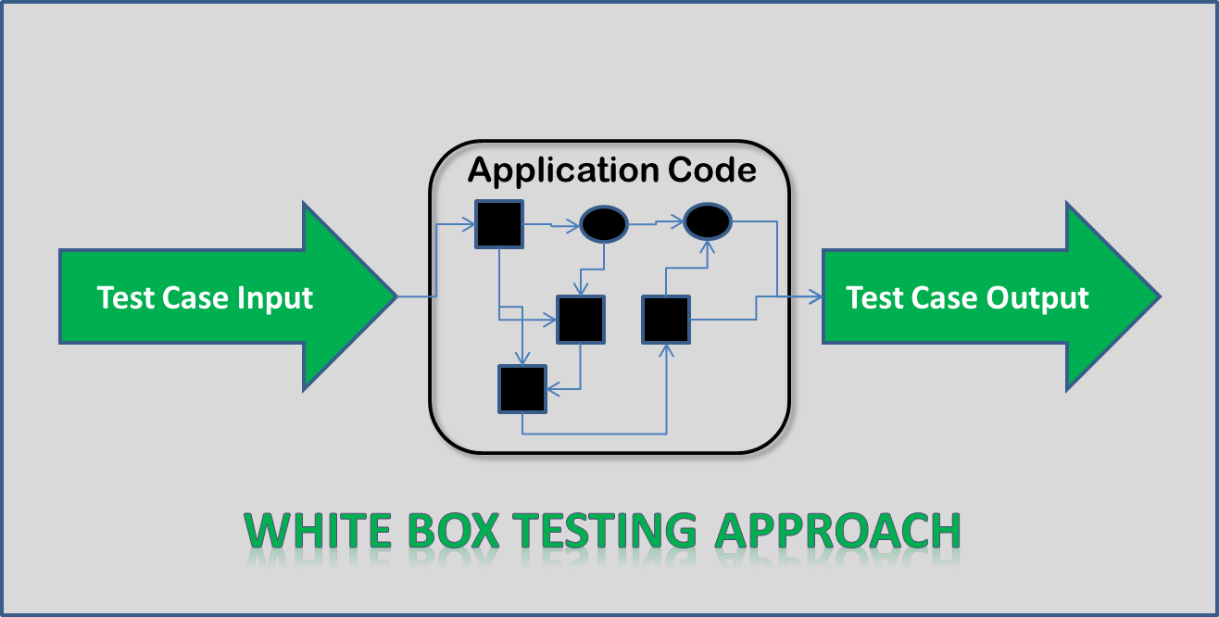

**Acceptance Testing**

**System Testing**

**Integration Testing**

**Unit Testing**

**Screen Shots**

**SCREEN SHOTS**

MAIN PAGE:

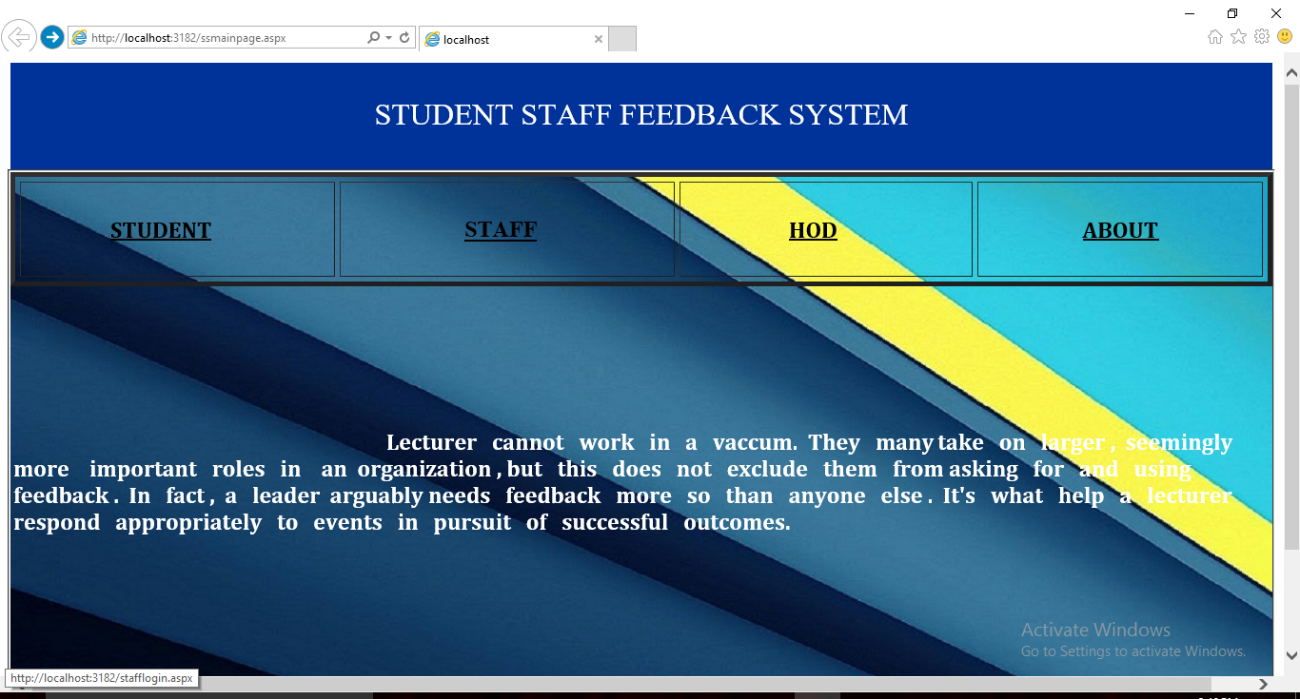

STUDENT LOGINPAGE:

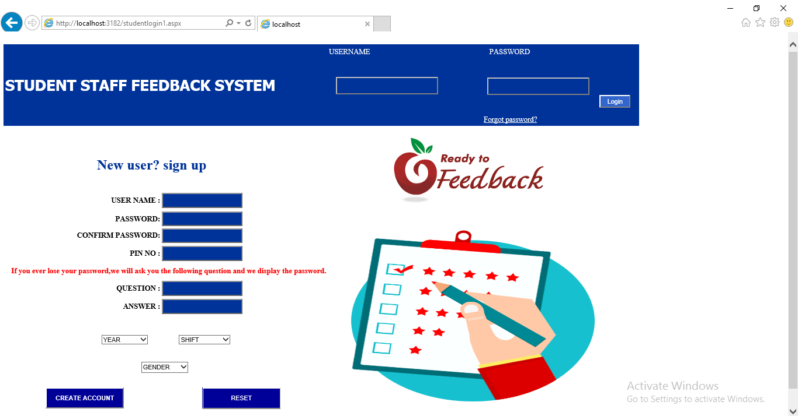

STUDENT FEEDBACK TO STAFF:

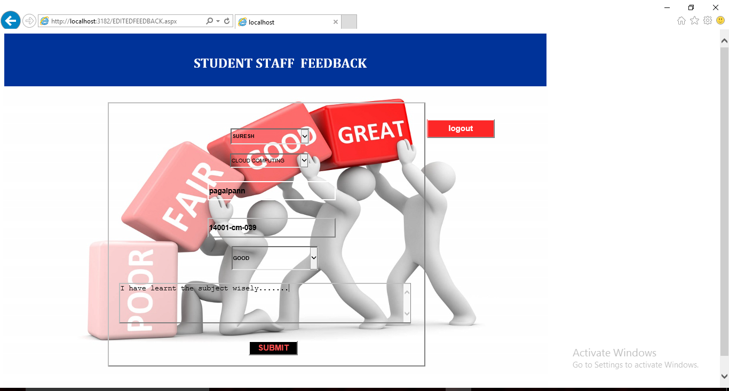

HOD’S HOMEPAGE:

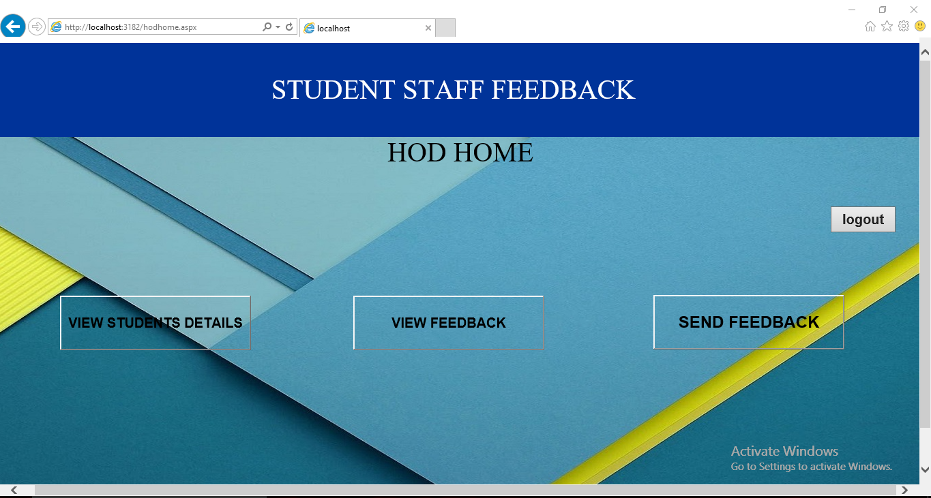

REGISTERED STUDENT DETAILS :

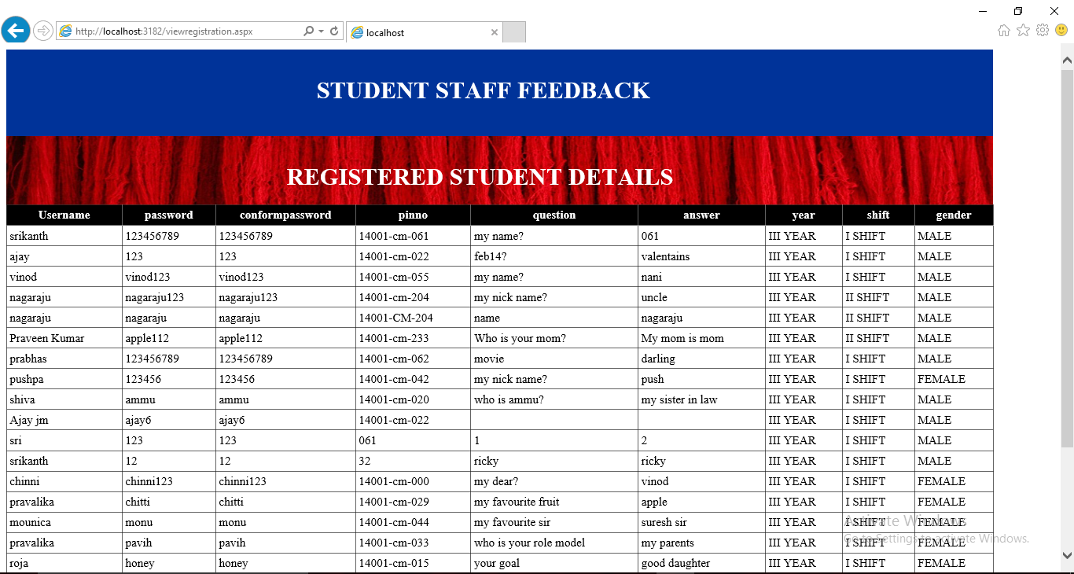

FEEDBACK OF STUDENTS TO STAFF:

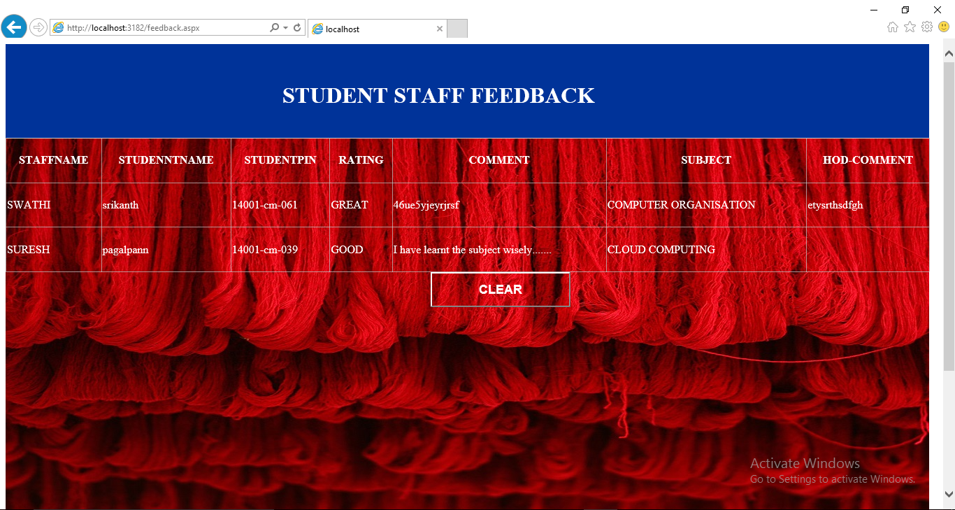

HOD’S FEEDBACK TO LECTURER:

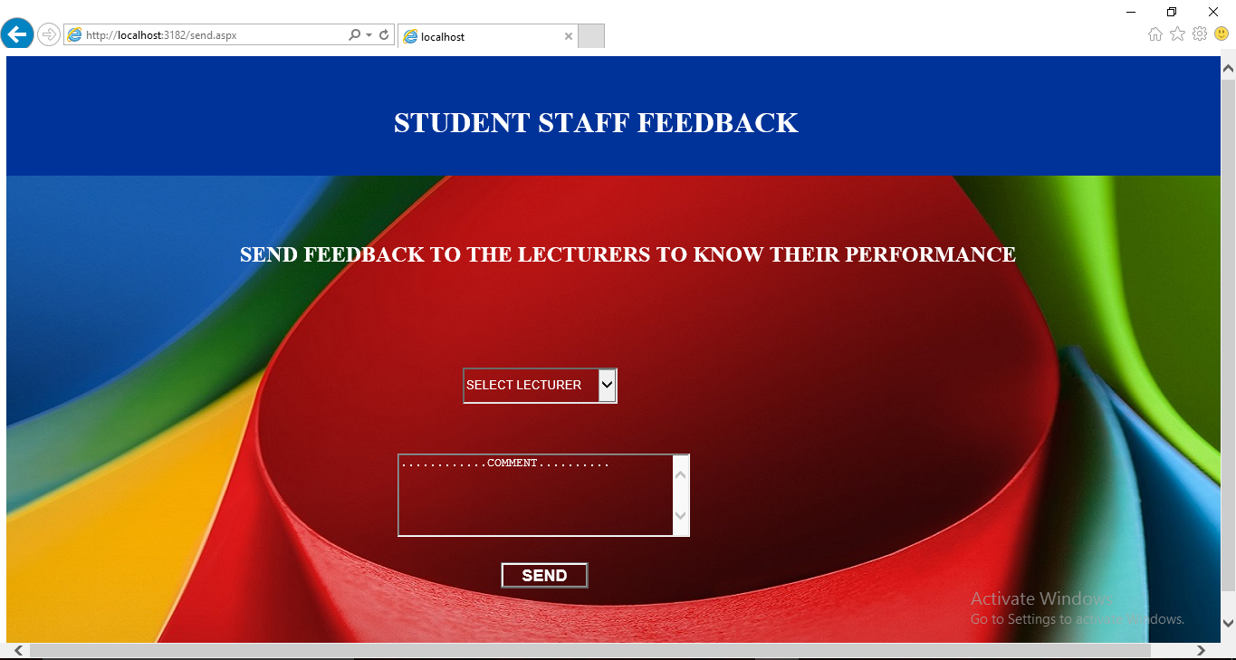

**Future Scope**

**FUTURE SCOPE**

This is not the overall description about the feedback system. Some more forms can also be added so as to better retrieve the feedback details. We implemented the system as per the college level as well as we will implement it in hotels, universities, private institutions, management offices etc.. Further enhancements can be made in designing the screens. Some more forms can also be added so as to better retrieve the feedback details. Some more design can also be added in the particular system.

**Conclusion**

**CONCLUSION**

This project is design for the purpose to reduce the lecturer’s time and to reduce the burden of maintaining huge amount of records of students. At the time of feedback generation it apply formulae for generate a feedback of particular subject. After that it will displayed the whole record sheet to the staff, when the staff will login in the system. As the comparison with Manuel feedback or existing feedback system the new system is easier way to manage whole things in a particular manner. As per the existing system it is very easy process to save each and every record of individual student by the use of database.

From a proper analysis of positive points and constraints on the component, it can be safely conclude that the product is a highly efficient GUI based component. This application is working properly and meeting to all user requirements. This component can be easily plugged in many others computers having the windows operating system. It has been thoroughly tested and implemented.

* It is developed in windows platform and have effective Graphics User Interface
* It has content management system (CMS) by

**Bibliography**

**BIBLIOGRAPHY**

1. The complete Reference of ASP.NET 4.0 latest Edition

2. Programming through c#

**Websites:**

[**http://www.dotnetspider.com**](http://www.dotnetspider.com)

[**http://www.asp.net**](http://www.asp.net)

[**http://www.c-sharpcorner.com**](http://www.c-sharpcorner.com) [**http://www.slideshare.net/akshaysurve53/student-feedback-system**](http://www.slideshare.net/akshaysurve53/student-feedback-system)[**https://en.wikipedia.org/wiki/Student_information_system**](https://en.wikipedia.org/wiki/Student_information_system)